**Project 02_01_01**

In this Project we will build a series of PHP applications to test our knowledge of the unit. Be sure to document al of your code to indicate your understanding.

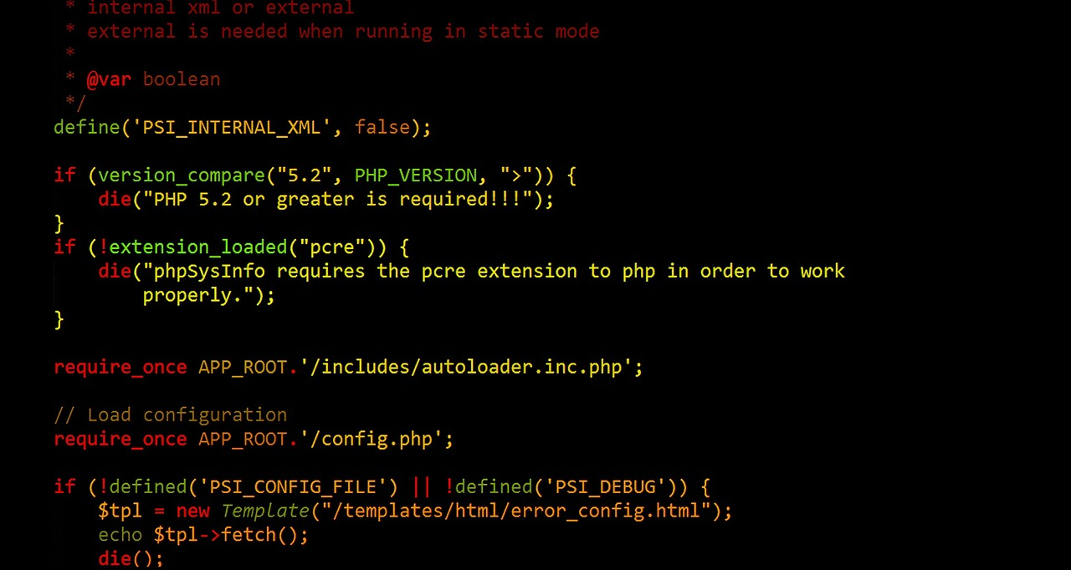 

**Part 01**

1. Create a new file called ***InterestArray.php***. Scaffold a basic HTML code layout into it. Set the <title> to ***Interest Array***. Make sure to have the ***modernizr*** <script> linked in. Perform a server/browser test.
2. Add an ***<h2>*** element to the body with the content set to ***Interest Array***. Place a set of PHP standard ***script*** ***delimiters*** in the <body> of the document.
3. Declare a series of 7 variables, named ***$interestRate1*** through ***$interestRate7***. Initialize them to the following values: ***.0725***, ***.0750***, ***.0775***, ***.0800***, ***.0825***, ***.0850***, ***.0875***.
4. Use an array constructor to create an array named ***$ratesArray*** and ***initialize*** its elements to the values that are stored in the variables.
5. Display all of the elements of the array, nicely labeled and formatted, with all interest rates displayed to 4 decimal places.

**Part 02**

1. Create a new file called ***DaysArray.php***. Scaffold a basic HTML code layout into it. Set the <title> to ***Days Array***. Make sure to have the ***modernizr*** <script> linked in. Perform a server/browser test.
2. Add an ***<h2>*** element to the body with the content set to ***Days Array***. Place a set of PHP standard ***script*** ***delimiters*** in the <body> of the document.
3. Write a script that assigns the days of the week to an array named ***$days[]***. Use output statements to display “***The days of the week in English are:*** “ along with the values in the $days[] array.
4. Following the output statements, reassign the values in the ***$days[]*** array with the days of the week in French. Sunday is ***Dimanche***, Monday is ***Lundi***, Tuesday is ***Mardi***, Wednesday is ***Mercredi***, Thursday is ***Jeudi***, Friday is ***Vendredi***, and Saturday is ***Samedi***. Then use output statements to display “***The days of the week in French are:*** “ along with the French values in the $days[] array.

**Part 03**

1. Create a new file called ***IsEven.php***. Scaffold a basic HTML code layout into it. Set the <title> to ***Is Even***. Make sure to have the ***modernizr*** <script> linked in. Perform a server/browser test.
2. Add an ***<h2>*** element to the body with the content set to ***Is Even***. Place a set of PHP standard ***script*** ***delimiters*** in the <body> of the document.
3. Use an array constructor to create an array named ***$numbersArray*** and ***initialize*** its elements to 10 random numbers.
4. Use the ***conditional*** operator, along with the ***modulus*** operator, to display each element of the array. Display all of the elements of the array, followed by “***is an even number.***” or “***is an odd number.***” Depending on the results of the conditional operator expression.